Voice Coach — Análisis de voz
Idioma: English · Duración: 25s · Palabras: 58 · Ritmo: 138 ppm · Positividad: 68% · Muletillas: 1 · Generado: 7/11/2026, 1:26:10 PM

Métricas
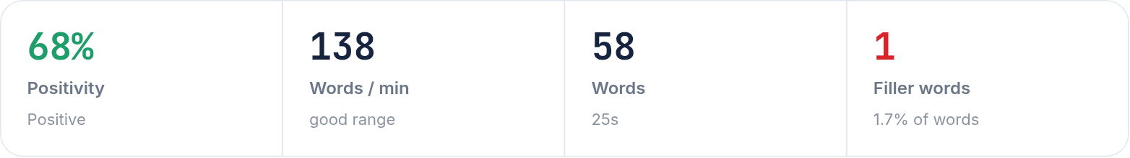

Arco de sentimiento
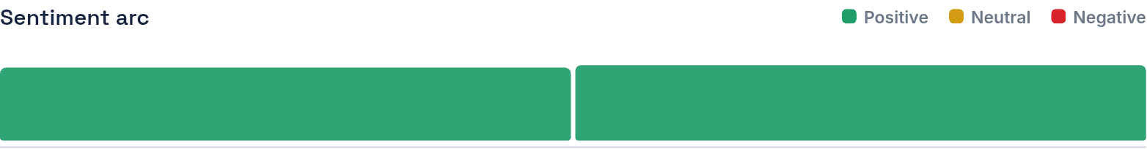

Transcripción
When the US-CADC is from the USA, come to Latin America, they are looking for competitive salaries and other who can speak Portuguese, like here, I decide to pursue a career in a corporate business education field. And currently, in studying chemistry and English, this is a true-fought path that through hard work, you can achieve new goals.
Color del texto — Verde: positivo · Amarillo: neutral · Rojo: negativo

